**UML Assignment**

1. **UML Diagram for Airline Reservation System**

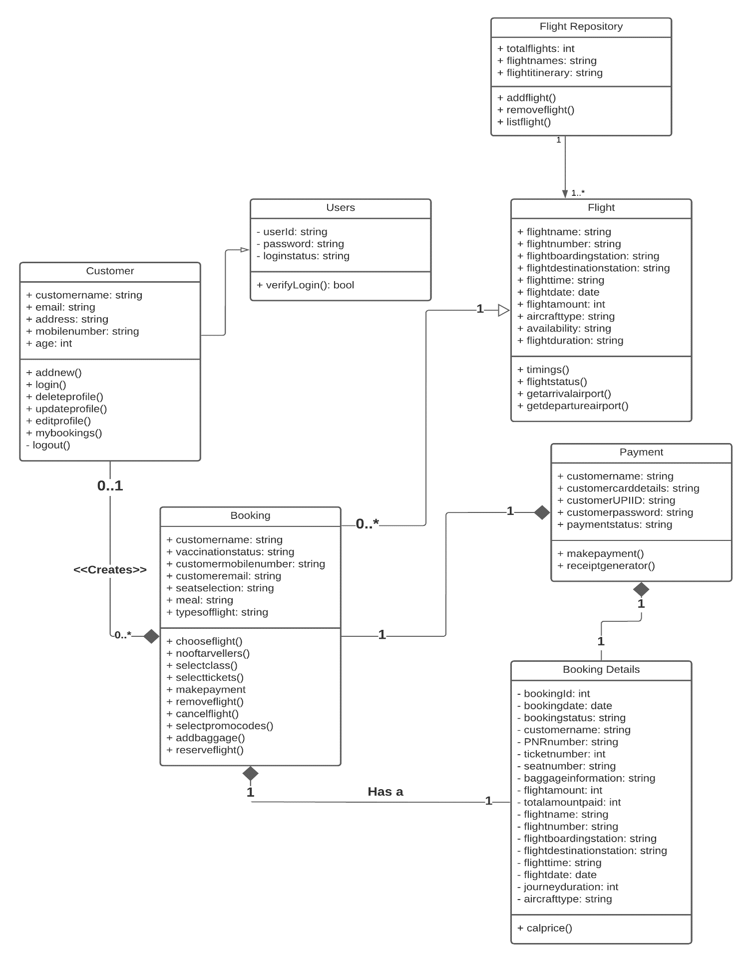

1. **UML Diagram for University and its Attributes**

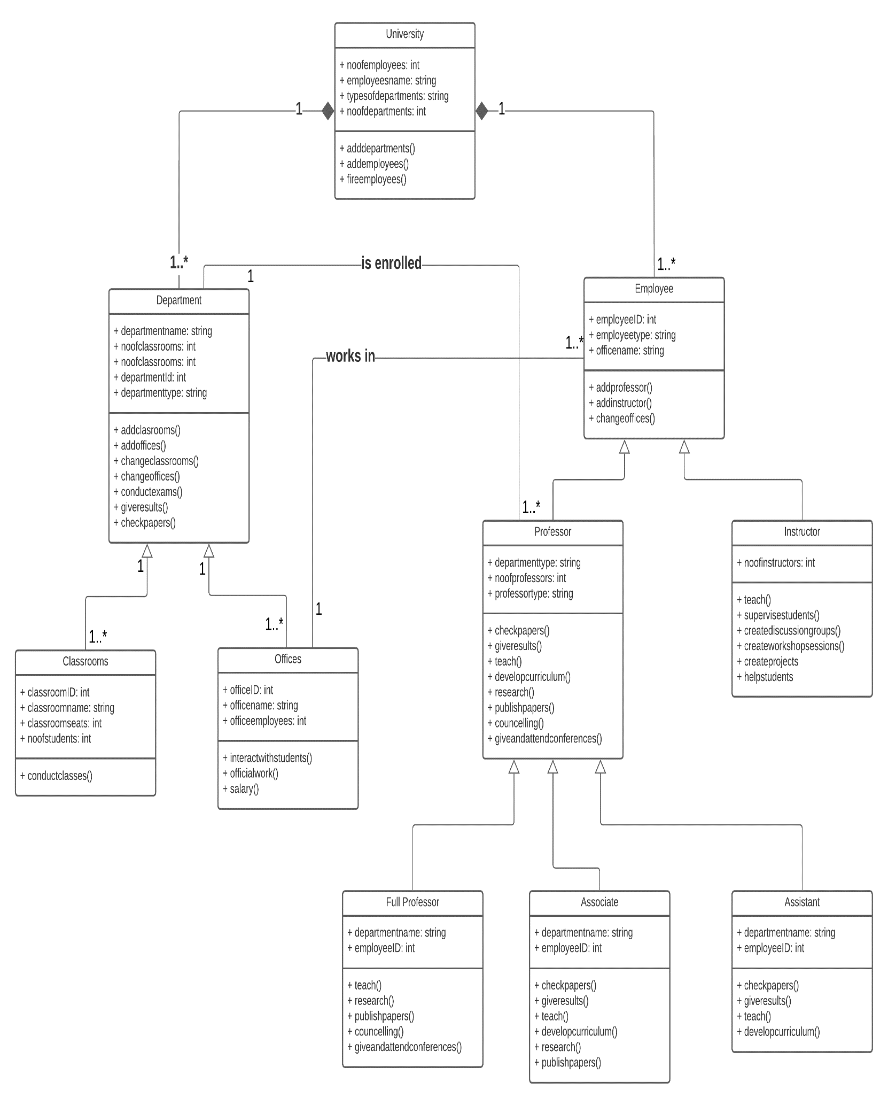

1. **Activity Diagram for Student Enrolment Form**

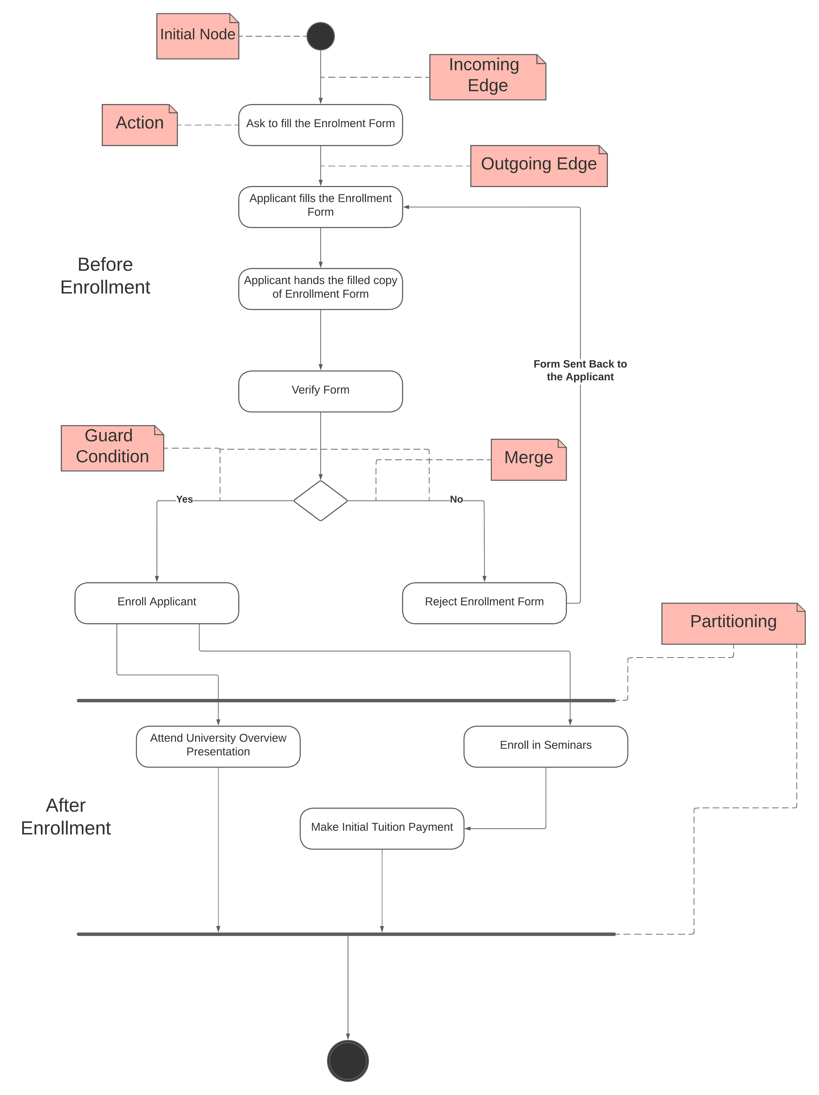

1. **Sequence Diagram for Online Library Management System**

